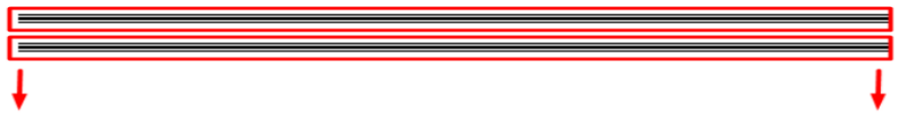
✿MOHAMED SAEED FARAJ JACOUB ELSAYDWEB✿

✿H ow to add background svg 3Dfor section And body ✿
// ✿H ow to add background svg 3Dfor section & And body ✿

الينك ده كويس فيه بلجنس كويهتفدنى جداااااا
https://speckyboy.com/particle-animation-code-snippets/
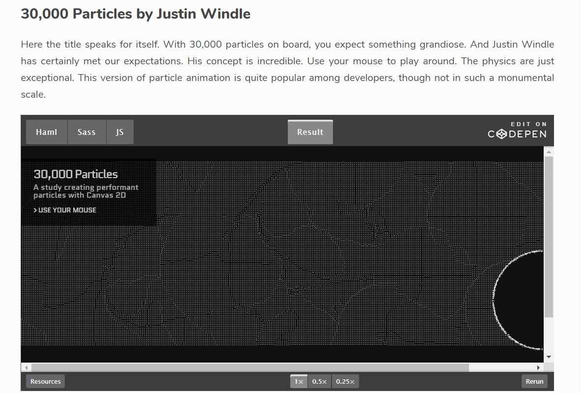
والينك ده فيه افكار كويسه برضو
https://www.jqueryscript.net/animation/Lightweight-jQuery-Plugin-For-Creating-Particles-Animation-Particles-js.html
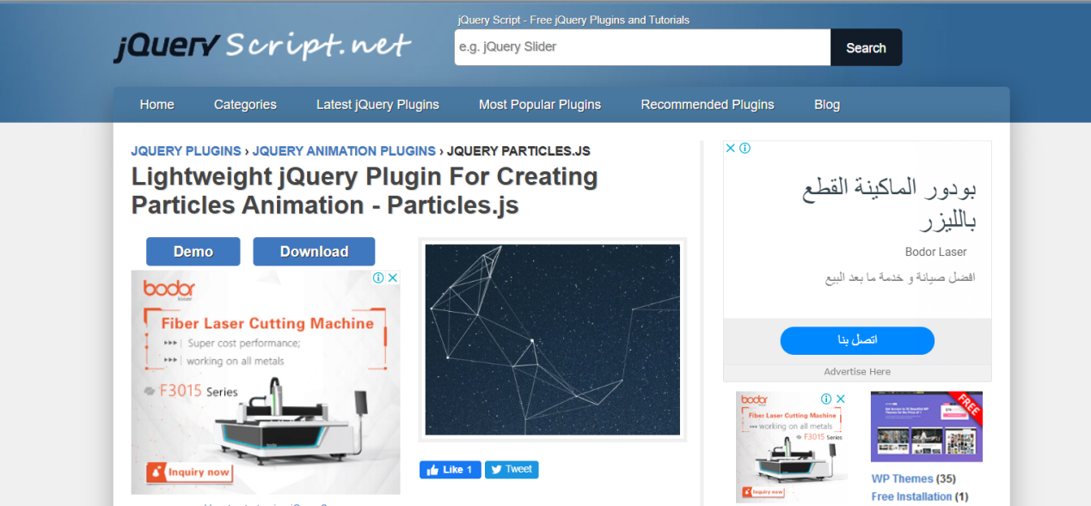

الينك ده في خلفيات GIF
https://www.google.com/search?q=Particles+img+gif&sxsrf=ALeKk03Xl56tGWPMNYNb-2Zw1FYr0GJMOA:1586053992960&tbm=isch&source=iu&ictx=1&fir=s5VDwVHtkvIySM%253A%252Ca9ATjjFB9XK9bM%252C_&vet=1&usg=AI4_-kTJrSZQ-7ATsFP-wDfxdoqxP4MaKg&sa=X&ved=2ahUKEwjS9eDGn9DoAhWiQEEAHbdjChUQ9QEwAXoECAoQGg#imgrc=pqmu2DNGv9iF7M
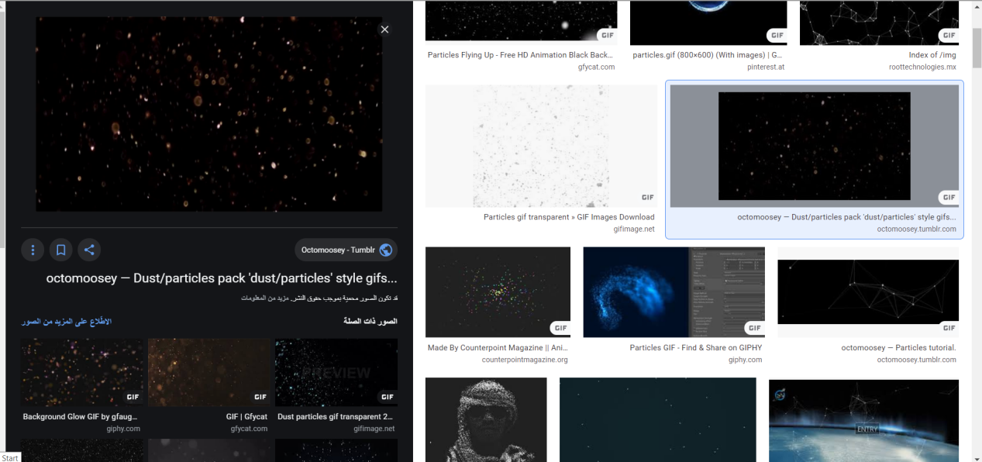

والينك ده برضو
https://octomoosey.tumblr.com/post/145051773972/dustparticles-pack-dustparticles-style-gifs
